**Why is NLP so hard?**

1. Ambiguity
2. Scale
3. Sparsity
4. Variation
5. Expressivity
6. Unmodeled variables
7. Unknown representations

**Corpus –** a collection of text (often annotated in some way)

**Zipf’s Law –** many modern phenomena can be modeled with a Zipf distribution

$\left({n \atop k}\right) = \frac{n!}{n!(n-k)!}$ number of ways to select k words out of n given words (“unordered samples without replacement”)

$\left({n \atop n_{1},n_{2},...,n_{k}}\right) = \frac{n!}{n_{1}!n_{2}!...n_{k}!}$ (number of ways to split n distinct words into k distinct groups of size n1, …, nk respectively

**Bag of words –** a fixed-length representation, which consists of a vector of word counts (sometimes equal to the size of the vocabulary V)

**Linear classifier – $ψ(x, y) = θf(x, y) =\sum{θ_{j}f_{j}(x, y)}$**

Our classification function is: $\hat{y} = {argmax}_{y} θf(x, y)$

**Naïve bayes –** a probabilistic classifier. It takes the following strategy:

1. Define a probability model p(x, y)
   1. Assume each instance is independent of the others
   2. Apply the chain rule of probability p(x, y) = p(x | y)p(y)
   3. Define the parametric form of each probability (e.g. p(y) = Categorical(mu) or p(x | y) = Multinomial(…) )
2. Estimate the parameters of the probability model by **maximum likelihood** – that is, by maximizing the likelihood of the dataset
3. NOT a step, just an attribute: p(y | x) = p(y)p(x1 | y)p(x2 | y)…p(xN | y) where x_i is a feature
4. Why is NB called naïve?
   1. Bayes rule is used to convert the observation probability p(x | y) into the label probability p(y | x)
   2. The multinomial distribution naively ignores dependencies between words, and treats every word as equally informative
   3. Discriminative classifiers avoid this problem by not attempting to model the “generative” probability p(x)

What is the probability of a word occurring N times given its probability of occurring is p? p^N

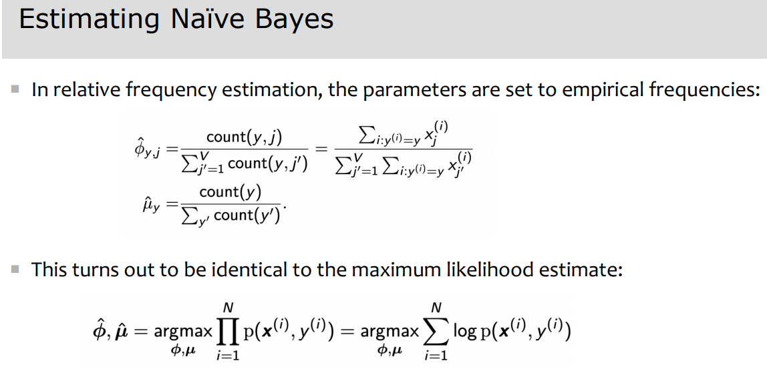

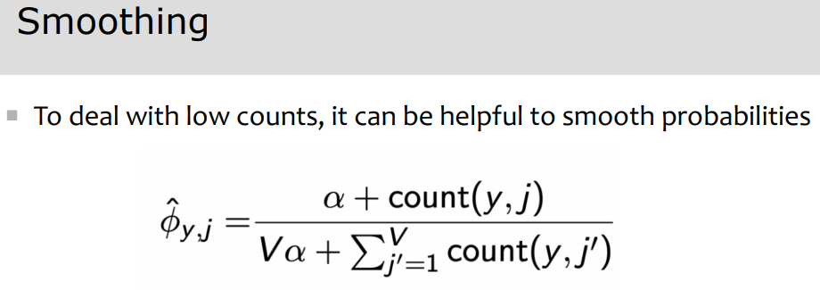

**Perceptron classifier –** error-driven rather than independence assumption

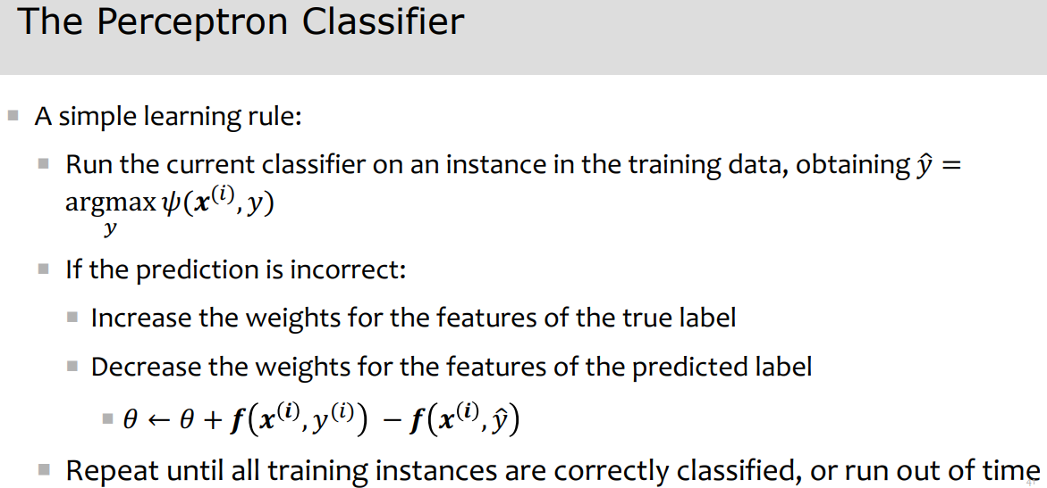

Minimizing a loss function on the weights should have two properties:

1. It should be a good proxy for the accuracy of the classifier
2. It should be easy to optimize

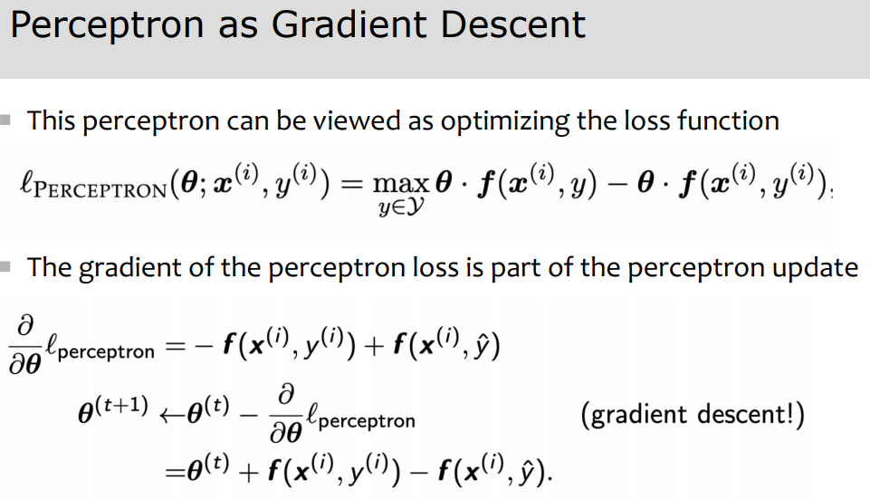

Perceptron classifier is discriminative – learns to discriminate correct and incorrect labels

Naïve Bayes is probabilistic – it assigns calibrated confidence scores to its predictions

Logistic regression is both discriminative and probabilistic – it computes the conditional probability of the label

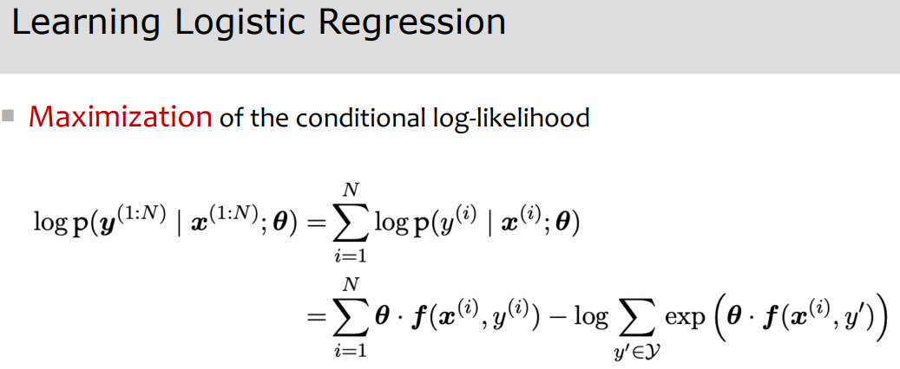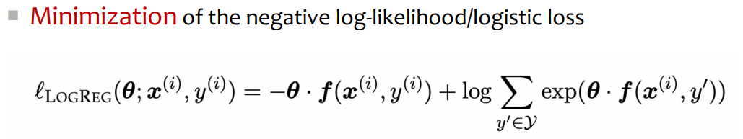

Stochastic gradient descent approximates the gradient by its value on a single sample

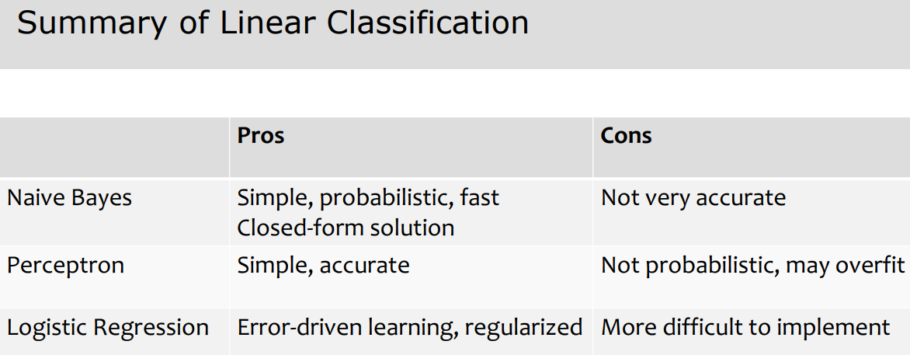

Derivative of sigmoid(x) = sig(x)(1 – sig(x))

Derivative of tanh(x) = 1 – tanh(x)^2

Softmax + negative log-likelihood loss = cross-entropy loss in deep learning

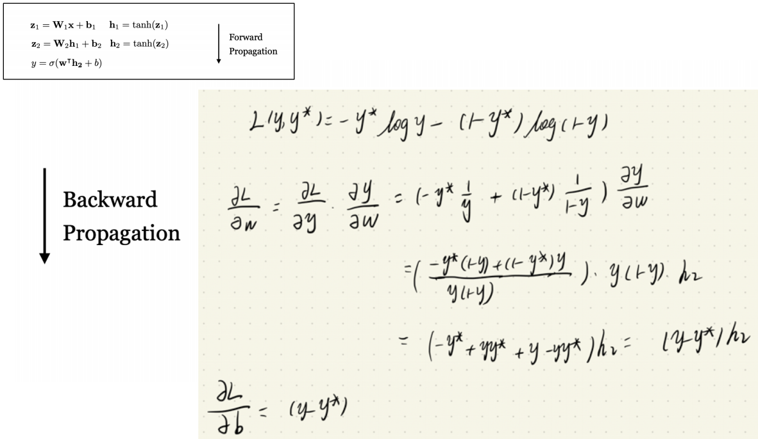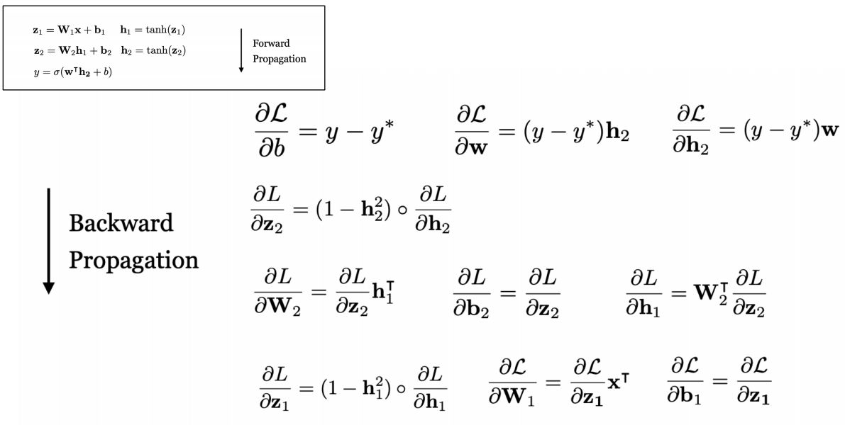

Tricks for better performance:

1. Prevent overfitting with regularization and dropout
2. Smart initialization
3. Online learning
4. Adaptive learning rates for each parameter
5. Most implementations clip gradients to some maximum magnitude before making updates
6. Early stopping

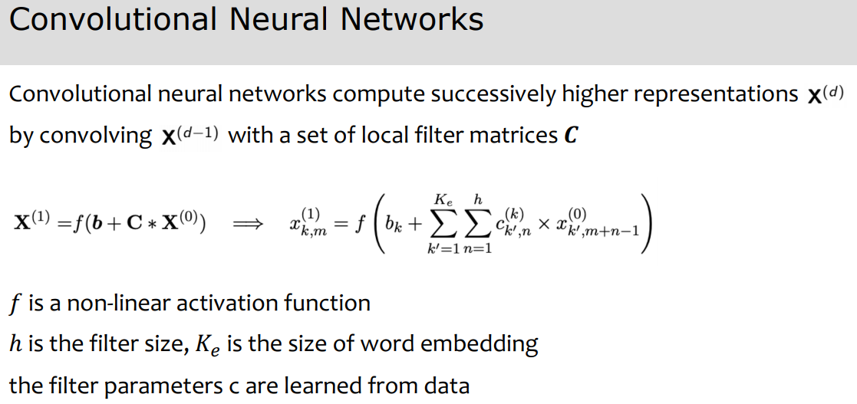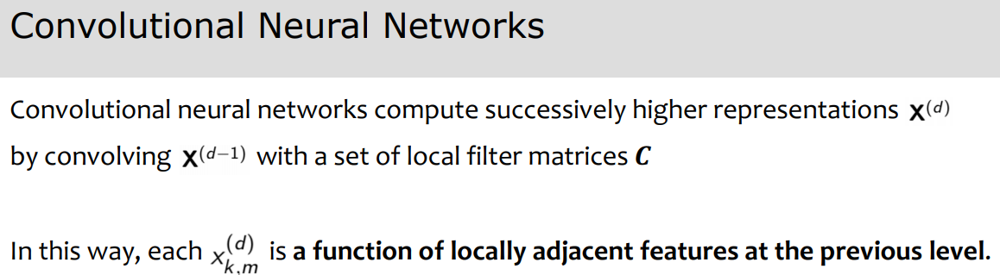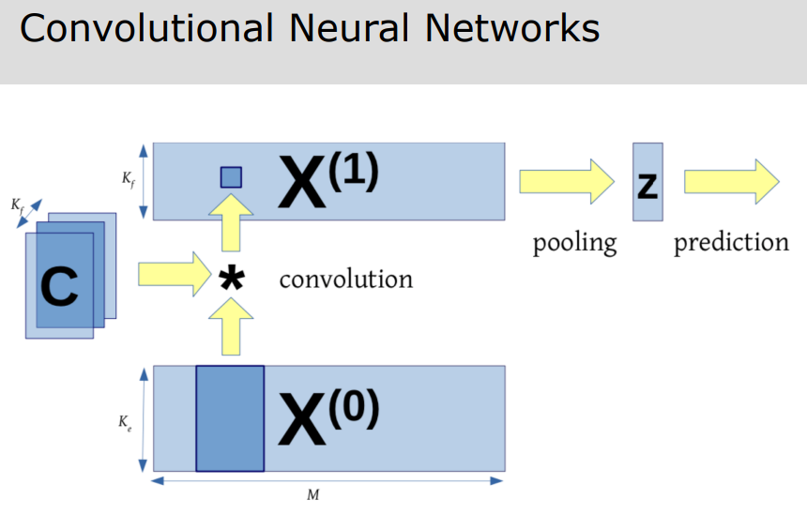

CNNs are sensitive to local dependencies between words. In RNNs, a model of context is constructed while processing the text from left to right. Those networks are theoretically sensitive to global dependencies.

Related classification problems:

1. Subjectivity: Does the text convey factual or subjective content?
2. Stance classification: Given a set of possible positions, or stances, which is being taken by the author?
3. Targeted sentiment analysis: What is the author’s attitude towards several different entities? (“The vodka was good, but the meat was rotten”)
4. Emotion classification: Given a set of possible emotional states, which are expressed by the text

**Stemming –** removing inflectional affixes (whales -> whale)

**Lemmatization –** converting to a base form (geese -> goose)

Stemming and lemmatization rarely help supervised classification, but can be useful for string matching and unsupervised learning

It can be useful to limit the vocabulary, as the number of model parameters generally scales with the vocabulary size

Evaluation metrics:

1. Accuracy (problem = doesn’t take into account precision/recall for unbalanced datasets)
2. Recall = TP / (TP + FN) (fraction of positive instances which were correctly classified)
3. Precision = TP / (TP + FP) (fraction of positive predictions that were correct)
4. F1 score = 2*recall*precision / (recall + precision) (tradeoff between just recall or just precision)
5. Recall and precision imply binary classification. In multi-class classification, each instance is positive for one class and negative for all other classes
6. Two ways to combine performance across classes:
   1. Macro F-measure: compute F-score per class, and average across all classes (treats all classes equally)
   2. Micro F-measure: compute the total number of TP, FP, and FN across all classes, and compute a single F-score. This emphasizes performance on high-frequency classes

Language models play the role of:

1. A judge of grammaticality
2. A judge of semantic plausibility
3. An enforcer of stylistic consistency
4. A repository of knowledge
5. Problem: assigning a probability to every sentence, even with finite vocab, can produce infinite sentences

A language model is a probability distribution over sentences: P(W) = p(w1, w2, w3, …, wk)

Can use them to generate strings: P(wk | w2, w3, …, wk-1)

Rank possible sentences: P(“today is Tuesday”) > P(“Tuesday today is”)

N-gram : a contiguous sequence of n tokens from a given piece of text

Unigram model: P(w1)P(w2)…P(wn)

Bigram model: P(w1)P(w2 | w1)…P(wn | wn-1)

Trigram model: P(w1)P(w2 | w1)P(w3 | w2, w1)…P(wn | wn-1, wn-2)

N-gram model: P(w1)P(w2 | w1)…P(wn | wn-1, wn-2, …, wn-N)

Markov processes: given a sequence of N random variables, we want a sequence probability model. There are |V|^n possible sequences

First order markov process: P(x1, x2, …, xn) = P(x1)P(xi | xi-1)

Second order markov process: P(x1, x2, …, xn) = P(x1)P(x2 | x1)P(xi | xi-1, xi-2)

Simplify notation; x0 = x(-1) = *

Maximum likelihood estimation: “best” means “data likelihood reaches maximum”: $\hat{θ}={argmax}_{θ}P(X | θ)$

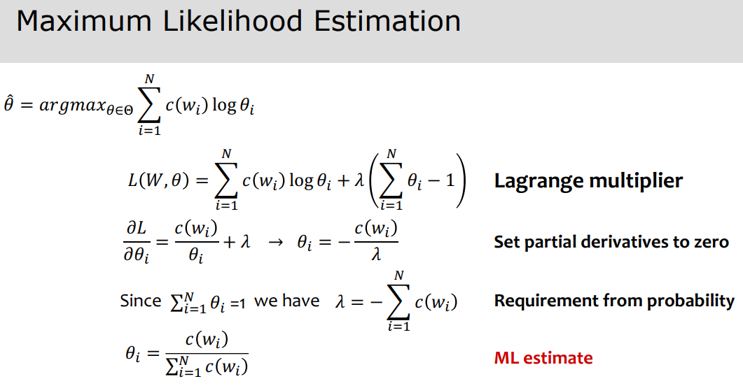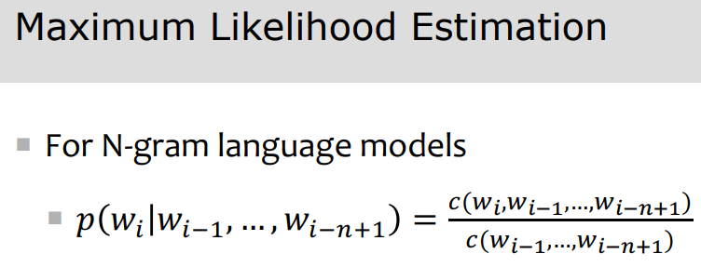

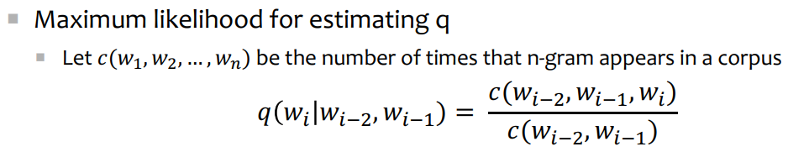

How to evaluate a language model:

1. Extrinsic: build a new language model, use it for some task (speech recognition, machine translation)
   1. Time-consuming
   2. Bad approximation unless test data looks just like training data (so, only useful in pilot experiments)
2. Intrinsic: measure how good we are at modeling language
   1. Perplexity
      1. Cannot compare perplexities of language models trained on different corpora

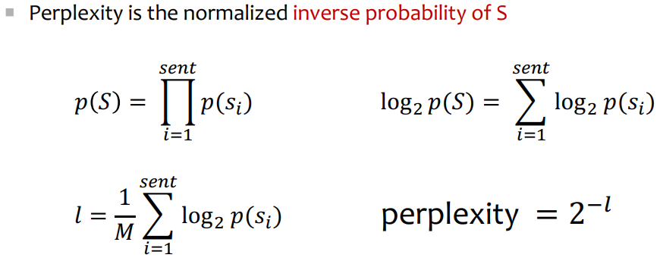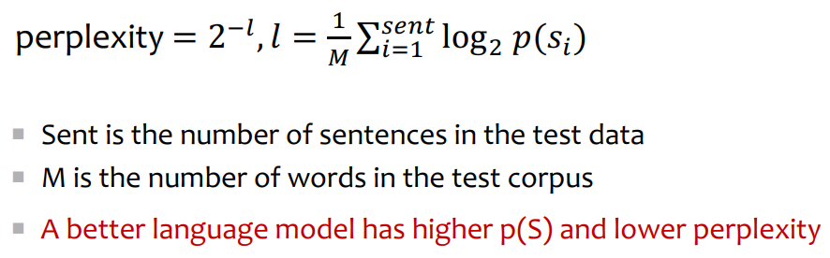

Problem with add one smoothing: with a large vocabulary, it thinks we are extremely likely to see novel events, rather than words we’ve actually seen (a large dictionary makes novel events too probable)

**Backoff –** use trigram if you have good evidence, otherwise bigram, otherwise unigram

**Interpolation –** mixture of unigram, bigram, trigram, etc. models

Interpolation works better than smoothing models

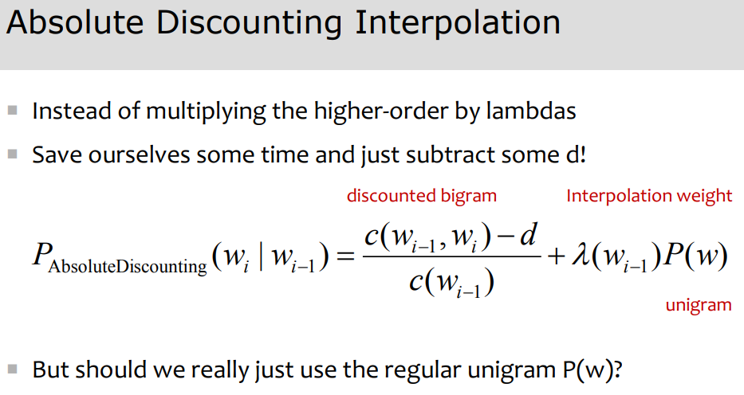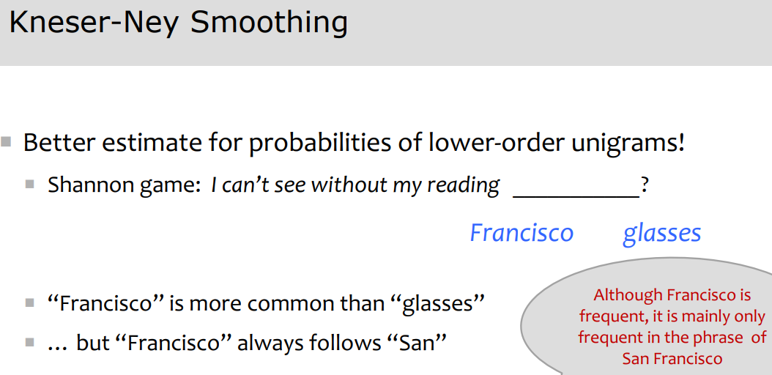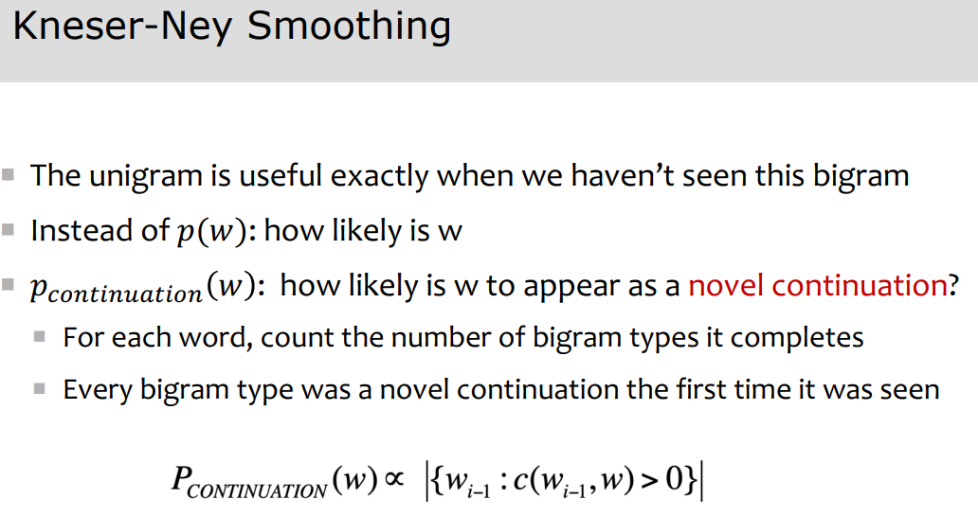

Kneser-Ney smoothing: words that have appeared in more contexts in the past are more likely to appear in some new context as well

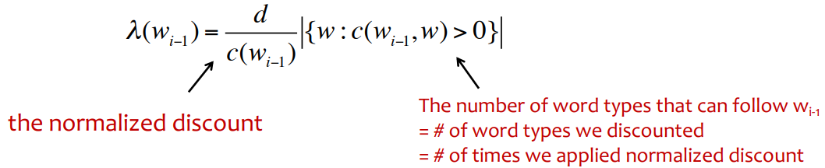

Distributed representations:

1. Store words in a trie instead of a set
2. Store words as indexes, not strings
3. Quantize probabilities
4. Variable length encoding
5. Fixed-window neural language model (no need to store all observed n-grams, no sparsity problem)
   1. Issues: fixed window is too small, enlarging window enlarges network, windows can never be large enough, different words are multiplied by completely different weights (no symmetry in how inputs are processed)

Language model evaluation: evaluate on likelihood of held-out data (averaged to normalize for length) through perplexity

How should we represent words as vectors?

1. Synonymity (couch/sofa, big/large, automobile/car). Problem is no examples of perfect synonymity
2. Antonymy (dark/light, short/long). They can define a binary opposition to each other, or be reverse
3. Similarity (words with similar meanings, e.g. car/bicycle, cow/horse)
4. Word relatedness (words can be related in any way, perhaps via a semantic field)
   1. **Semantic field –** a set of words which cover a particular semantic domain and bear structured relations with each other. For example “hospital” is a semantic field covering surgeon, scalpel, nurse, anesthetic, hospital
5. Superordinate/subordinate (basically just super/subclasses, e.g. car is a subordinate of vehicle)
6. Taxonomy (furniture -> chair, lamp, table -> office chair, piano chair, desk lamp, end table, coffee table)
7. (lexical semantics) Semantic frame. Frames have semantic roles (like buyer, sellers, goods, money) and words in a sentence can take on those roles
8. (lexical semantics) Connotation and sentiment. Connotations refer to the aspects of a word’s meaning that are related to a writer or reader’s emotions, sentiment, opinions, or evaluations. There are three dimensions of affective meaning (valence = pleasantness of the stimulus, arousal = intensity of emotion, dominance = degree of control exerted by the stimulus). For example, music = [7.67, 5.57, 6.5], courageous = [8.05, 5.5, 7.38], etc.
9. Discrete representation’ problems: too coarse, sparse, subjective, expensive, and hard to compute word relationships

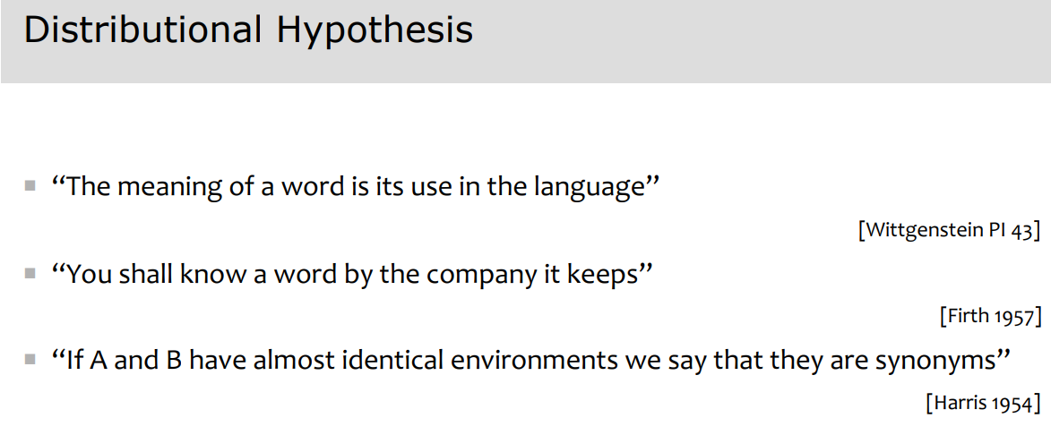

Word embedding representations:

1. Count-based (tfidf, PPMI)
2. Class-based (brown clusters)
3. Distributed prediction-based embeddings (word2vec, fasttext)
4. Distributed contextual (token) embeddings from language models (Elmo, BERT)

TFIDF (term-frequency inverse document frequency):

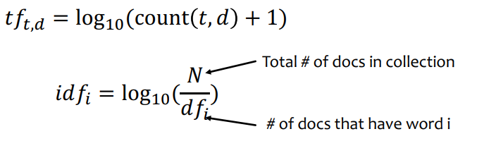 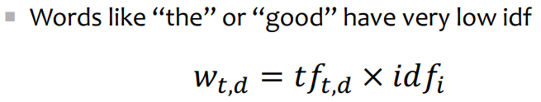

PMI (Pointwise Mutual Information):

Do word w and c co-occur more than if they were independent

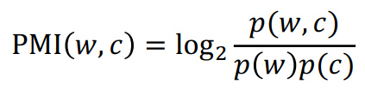

PPMI (Positive Pointwise Mutual Information):

PMI is biased toward infrequent events. Very rare words have very high PMI values. We want to give rare words

slightly higher probabilities

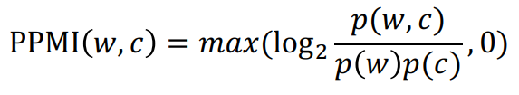 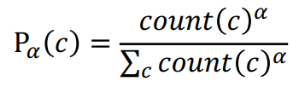

PPMI vectors are long and sparse. We want to learn vectors that are short and dense

Why? Short vectors easier to use as features, and dense vectors may generalize better than storing explicit

counts. Also, in practice, they work better

How to get short, dense vectors?

1. SVD (a special case of this is called LSA – Latent Semantic Analysis)
2. Brown clustering
3. Neural language modeling (skip-grams and CBOW – Continuous bag-of-words)

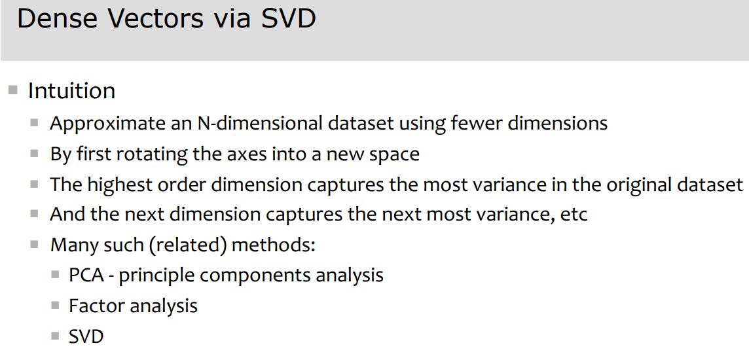 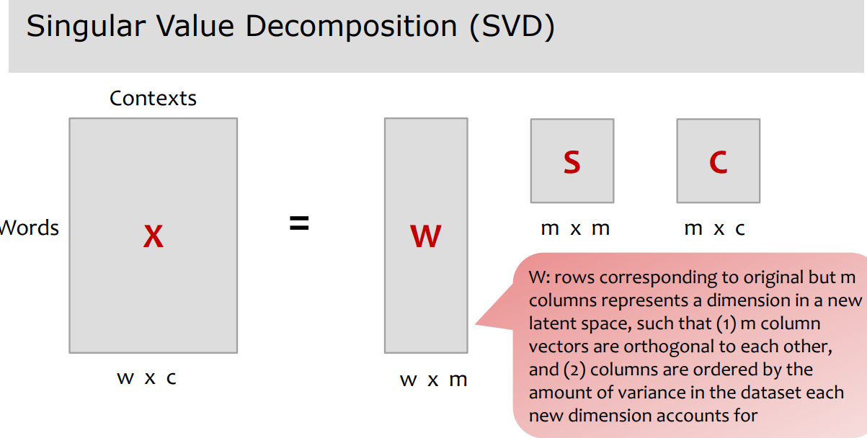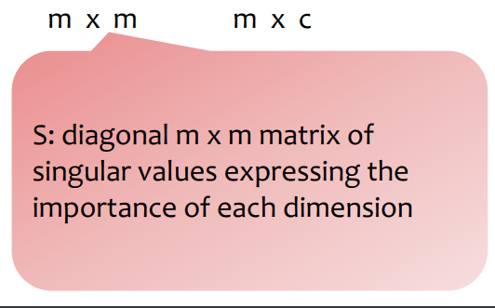 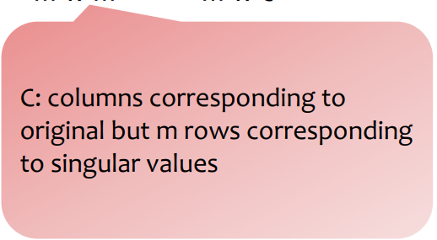

If instead of keeping all m dimensions, we just keep the top k singular values, the result is a least-square approximation to the original X

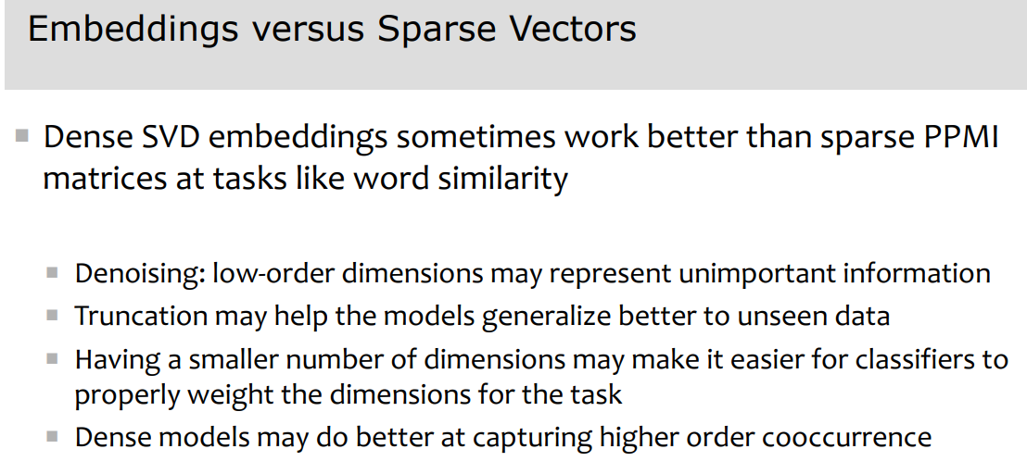

Word similarity is measured through cosine similarity dot(v, w) / [ norm(v) * norm(w) ]

Brown clustering:

Input: a large collection of words

Output 1: a partition of words into word clusters

Output 2 (generalization of 1): a hierarchical word clustering

Brown clustering is an agglomerative clustering algorithm that clusters words based on which words precede or follow them

Intuition: 1) similar words appear in similar contexts and 2) similar words have similar distribution of words to their

immediate left and right

Steps:

1. Each word is initially assigned to its own cluster
2. We now consider merging each pair of clusters. Highest quality merge is chosen.
   1. Quality = merges two words that have similar probabilities of preceding and following words
3. Clustering proceeds until all words are in one big cluster

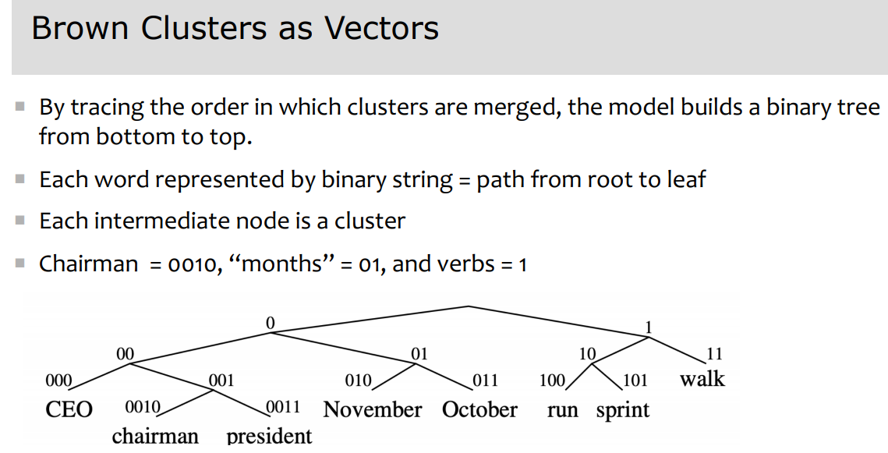 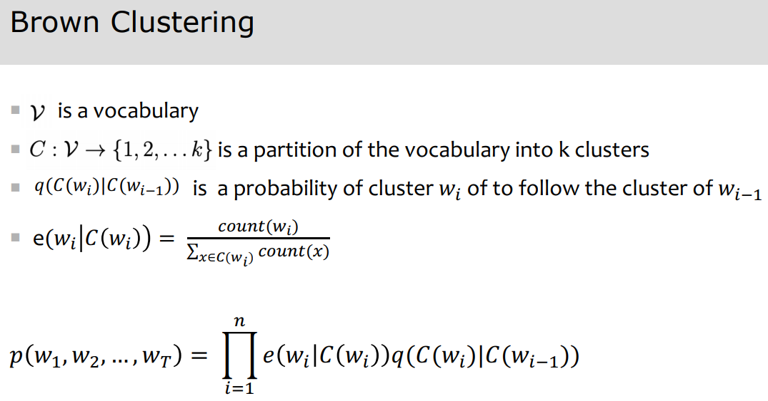

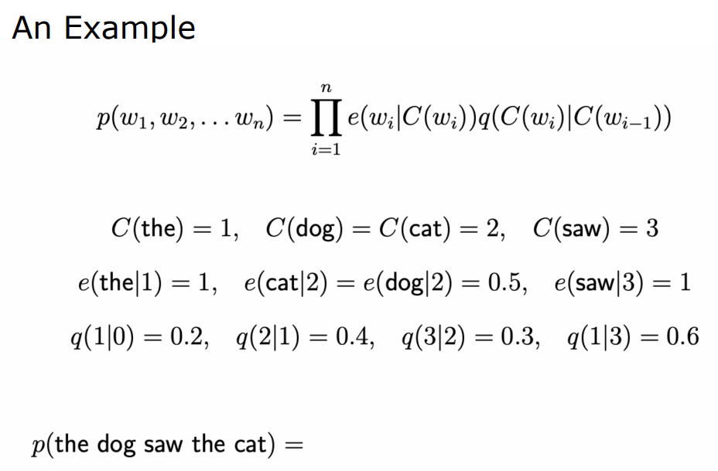 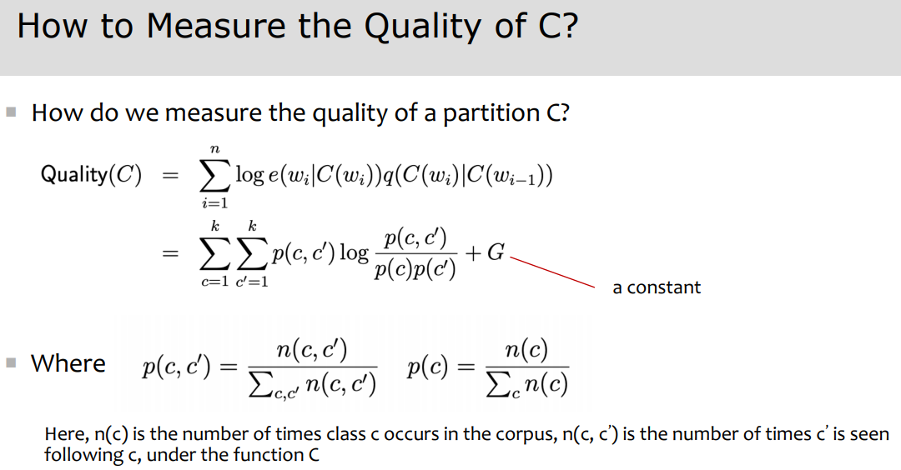 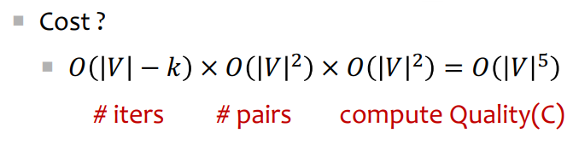

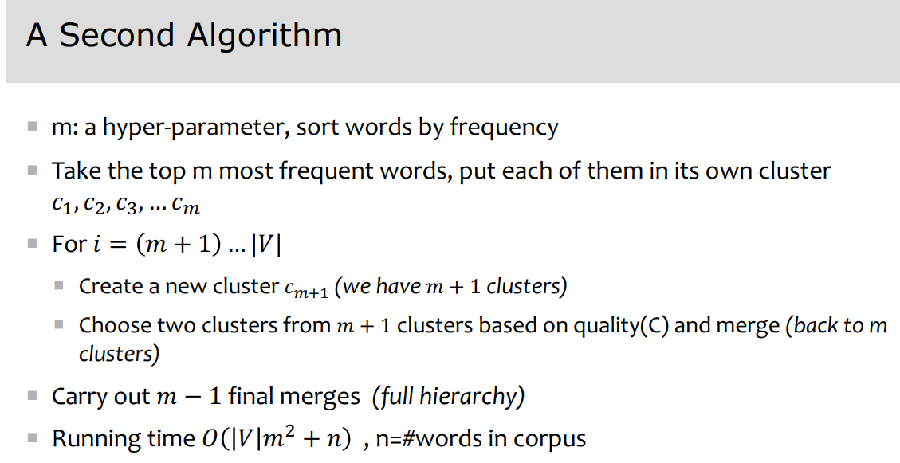 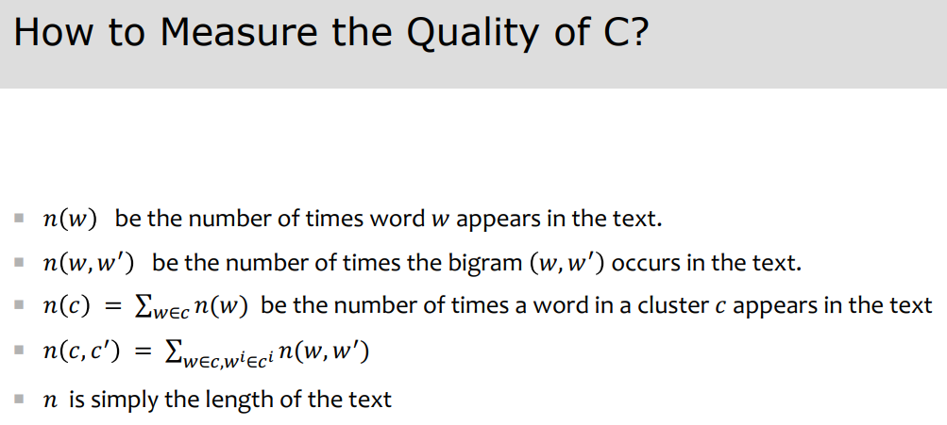 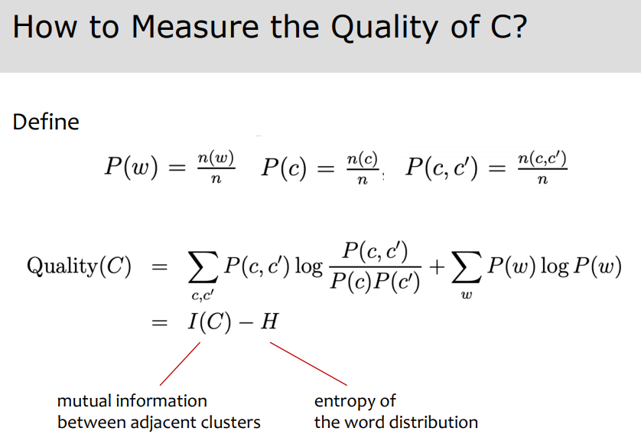

**Word2vec –** a popular embedding method, very fast to train, want to predict rather than count

Similar to language model, but predicting next word is not the goal. Want semantically similar words to have similar vectors

Embeddings that are good at predicting neighboring words are also good at representing similarity

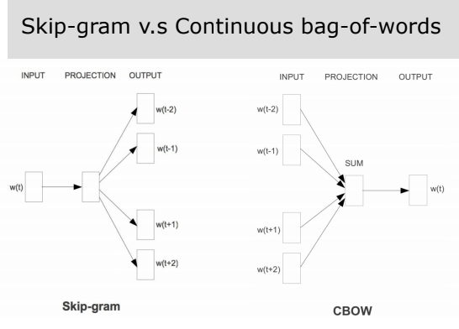

Skip-grame:

1. Treat the target word and neighboring context word as positive examples
2. Randomly sample other words in the lexicon to get negative samples
3. Use logistic regression to train a classifier to distinguish those two cases
4. Use the weights as embeddings

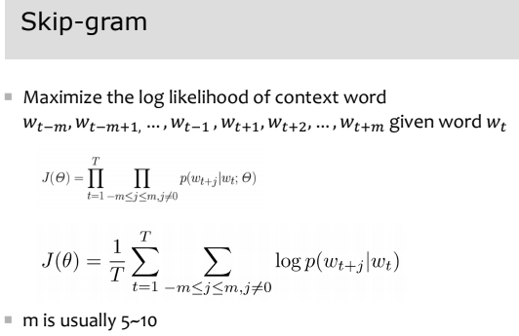 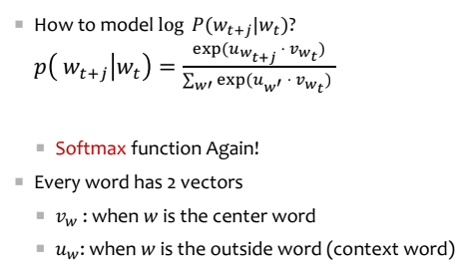 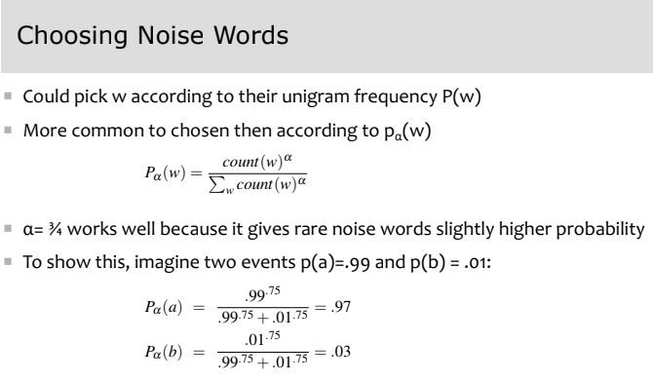

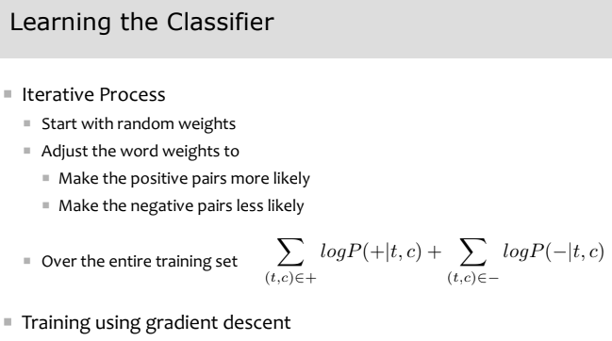 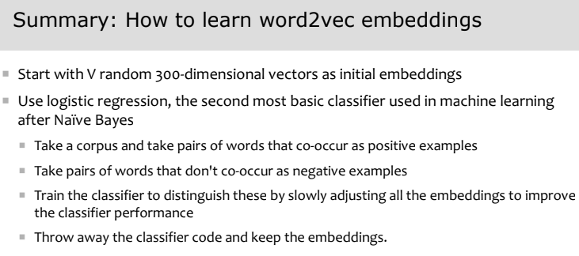

How to evaluate embeddings? Compare to human scores on word similarity tasks (e.g. WordSim-353)

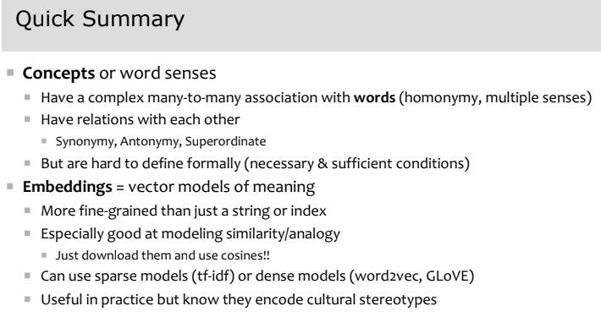 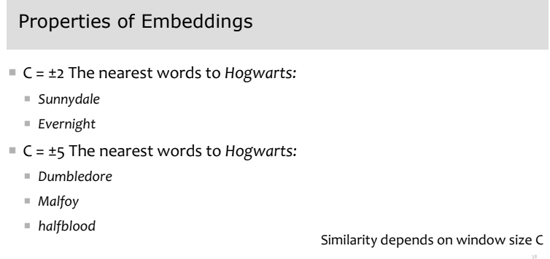

Embeddings reflect:

1. Cultural bias
2. Ethnic stereotypes over time

**Parts of speech –**

1. (N) Noun (London)
2. (PRO) Pronoun (he, him, she, her)
3. (ADJ) Adjective
4. (V) Verb
5. (ADV) Adverb (quickly)
6. (P) Preposition (shows the relationship of a noun or pronoun to another word, e.g. “on”, “for” in “I left my keys on the table for you”
7. Conjunction (and)
8. Interjection (Wow!)
9. (DET) Determiner (the, a, that, those)

Part of speech tagging – the process of assigning a POS tag to each word in a collection/sentence

Useful for parsing, information extraction (finding names/relations), speech synthesis, machine translation

Closed class – a small fixed membership (prepositions: of, in, by, …); usually function words (short common words which

play a role in grammar)

Open class – new ones can be created (e.g. nouns, verbs, adjectives, adverbs)

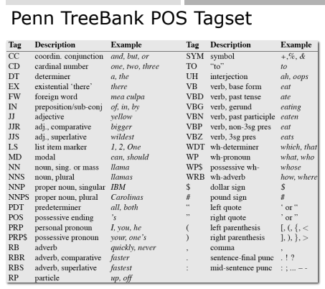

Use a Hidden Markov Model (HMM) for part-of-speech sequence tagging

“What is the most likely sequence of tags for the given sequence of words?”

Two useful pieces of info:

1. Relations between words and tags
2. Relations between tags and tags

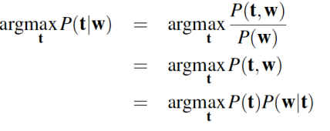 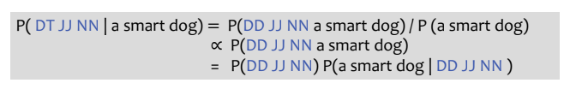

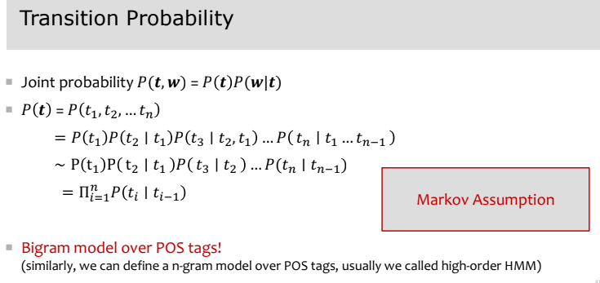 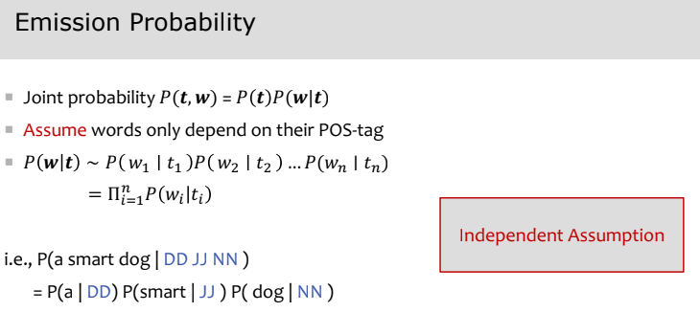 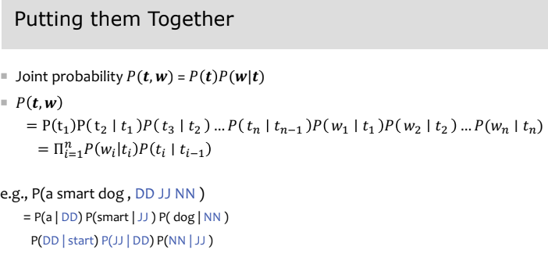

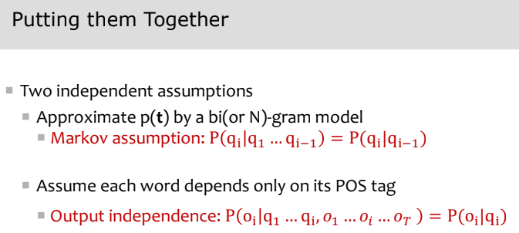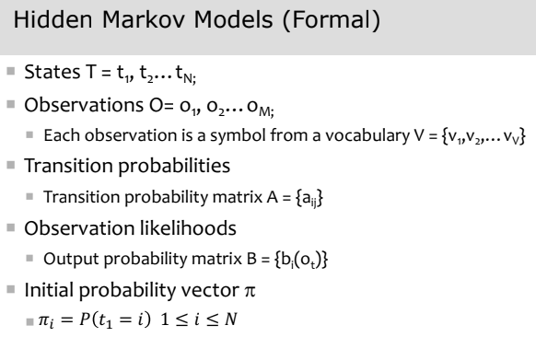

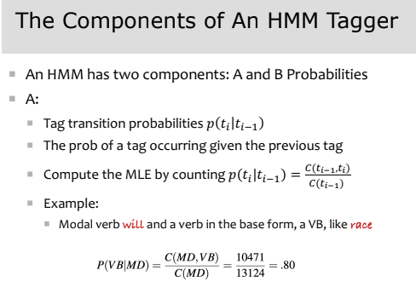 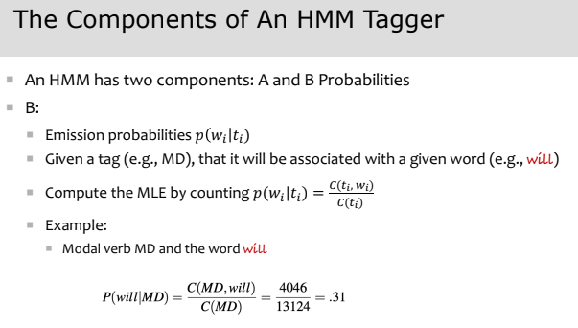 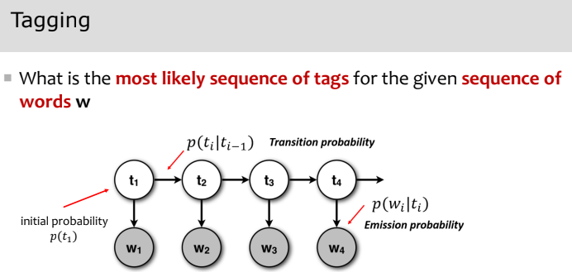 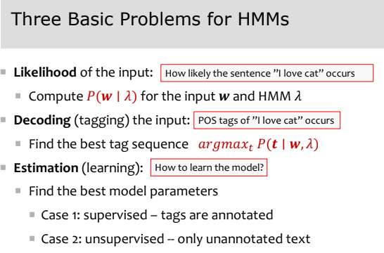 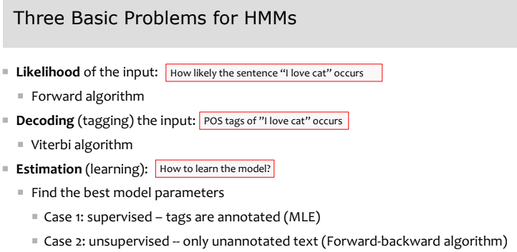 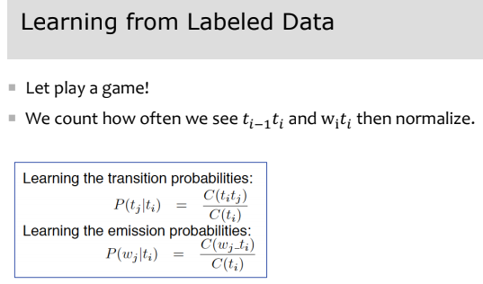 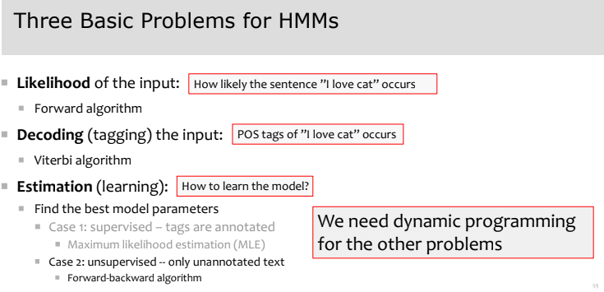 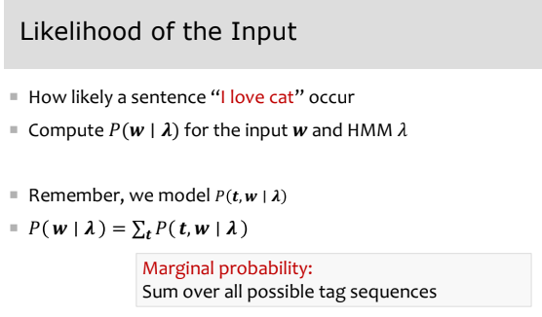 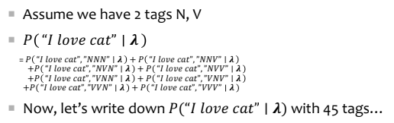

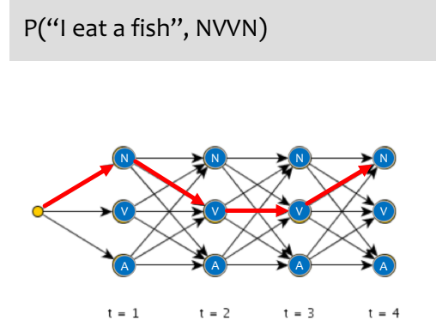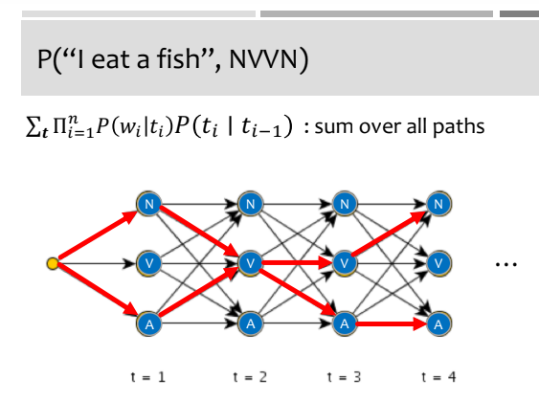 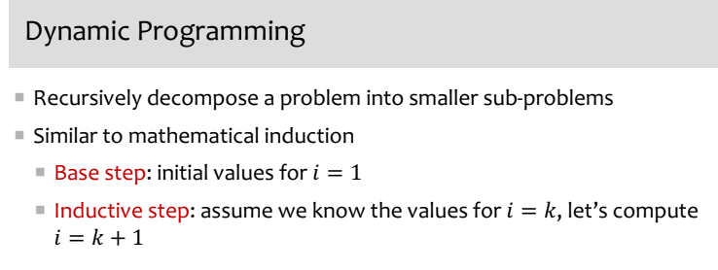 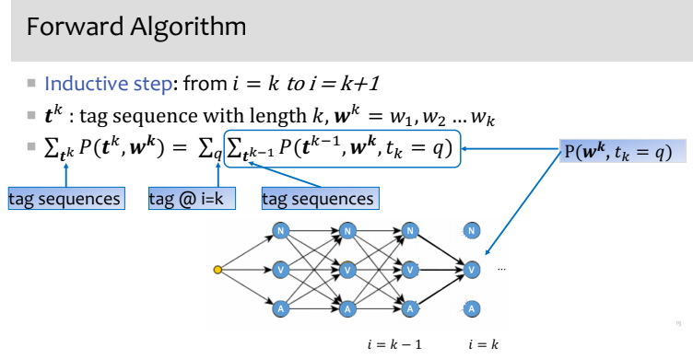 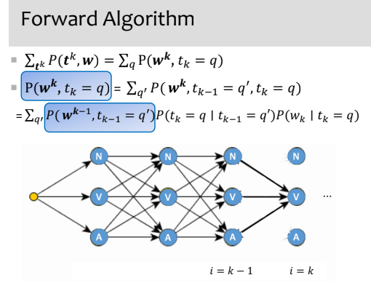 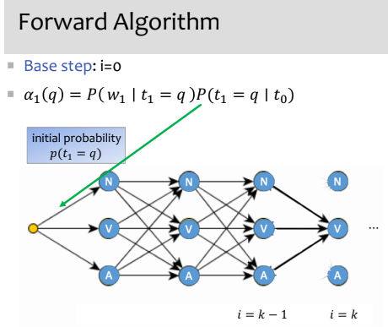

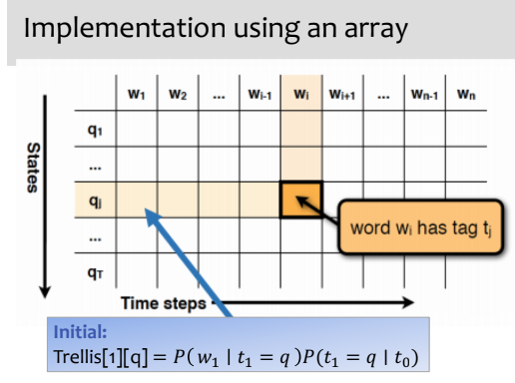 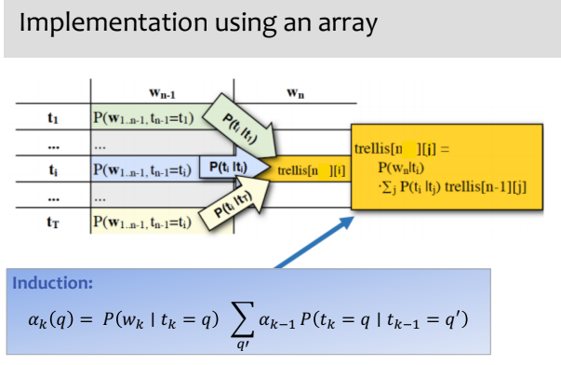 End of forward algorithm

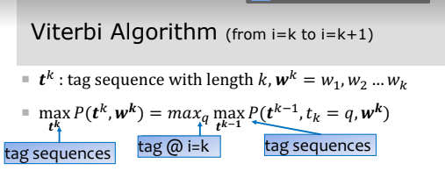 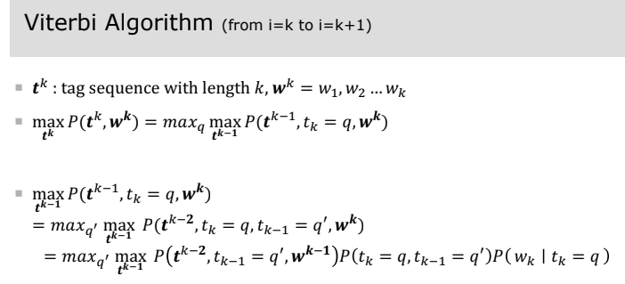 Begin Viterbi

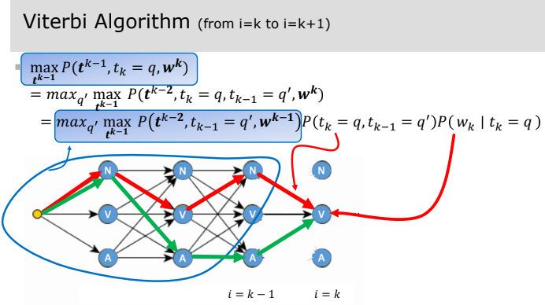 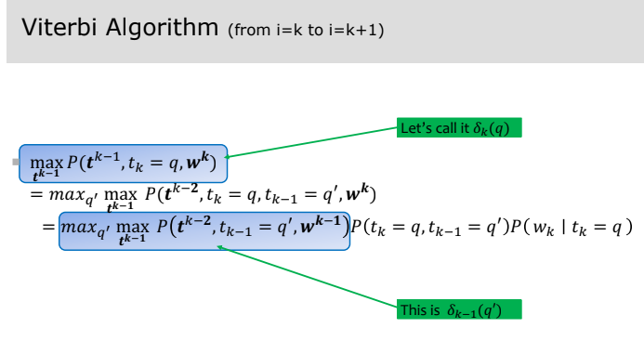 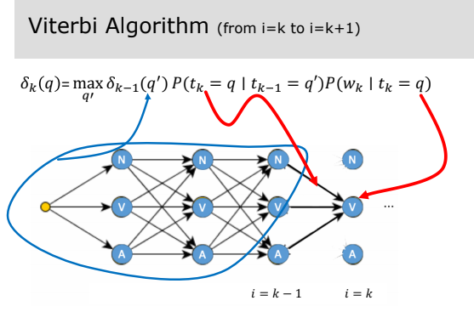

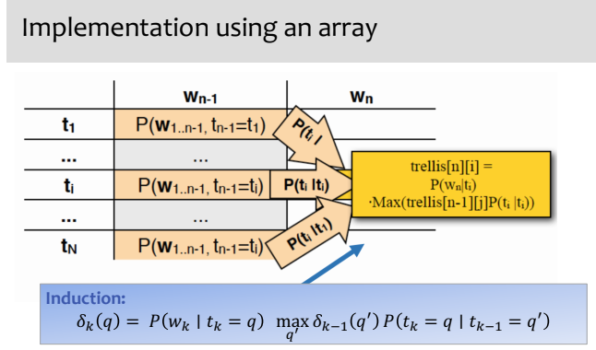 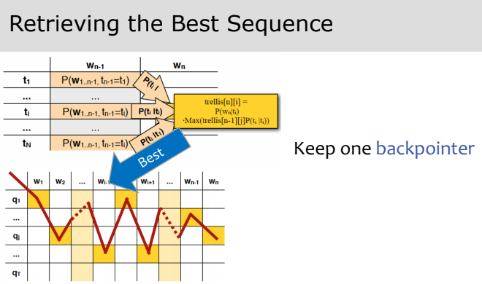 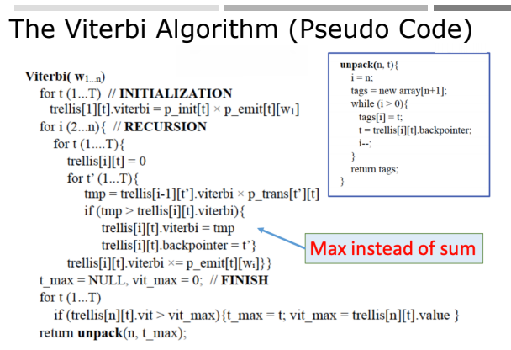

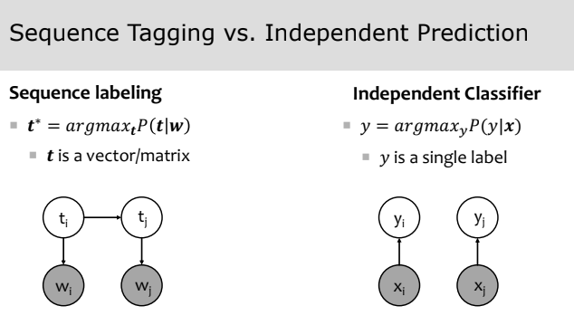 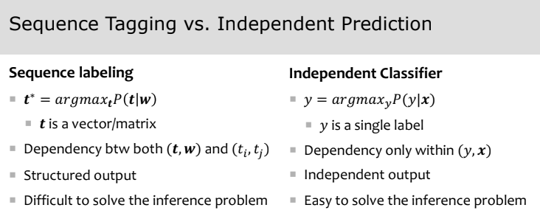

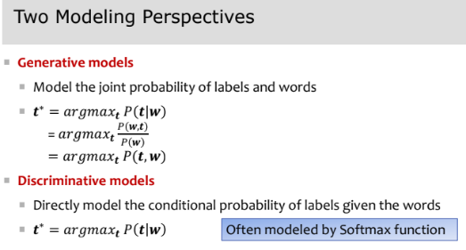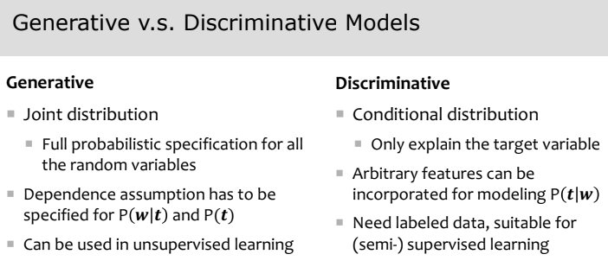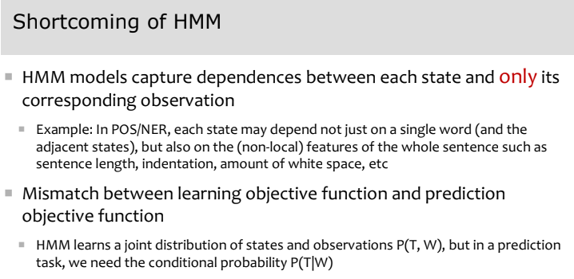

**Syntax –** refers to the way words are arranged together, and the relationship between them

Goal of syntax is to model the knowledge that people unconsciously have about the grammar of their native language

Why is syntax important?

1. Grammar checkers
2. Question answering
3. Information extraction
4. Machine translation

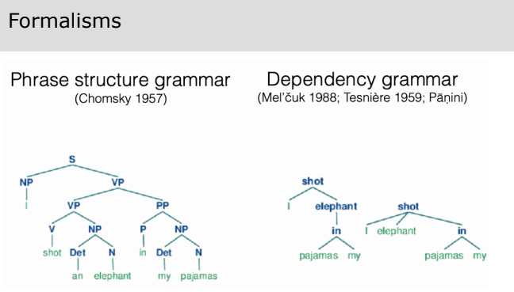

**Constituency –** group of words (“constituents”) behave as single units – “behave” = show up in the same distributional environments

- How words group into units and how the various kinds of units behave

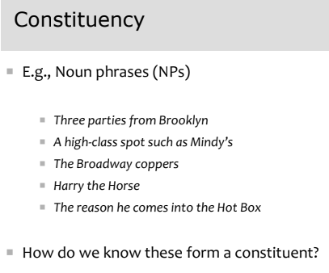

**Context-free grammar –** a CFG gives a formal way to define what meaningful constituents are and exactly how a constituent is formed out of other constituents (or words). It defines **valid structure** in a language.

- A context-free grammar defines how symbols in a language combine to form valid structures

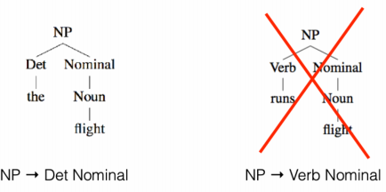 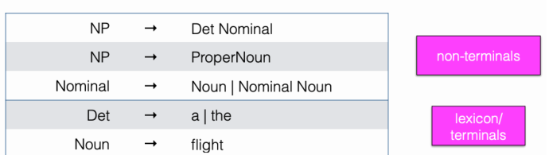 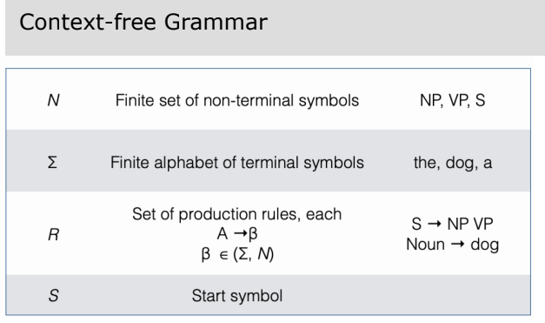

**Derivation –** given a CFG, a derivation is the sequence of productions used to generate a string of words (e.g. a sentence), often visualized as a parse tree

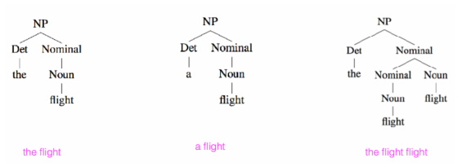

**Formal language –** the formal language defined by a CFG is the set of strings derivable from S (start symbol)

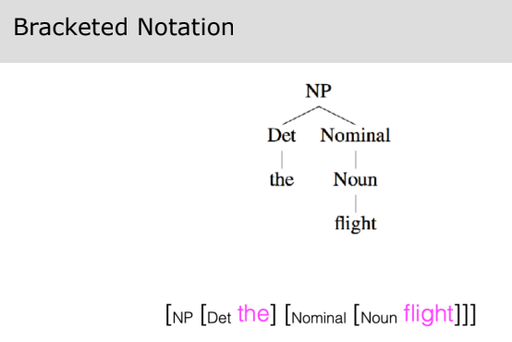 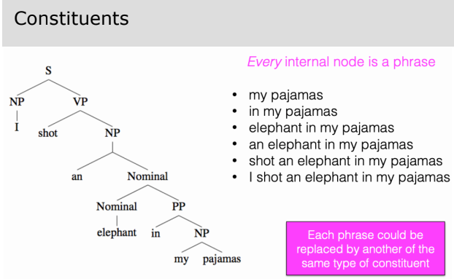

Some grammar rules in English:

1. S -> VP (Imperatives “Show me the right way”)
2. S -> NP VP (Declaratives “The dog barks”)
3. S -> Aux NP VP (Yes/no questions “Will you show me the right way?”)
4. S -> Wh-NP VP (Wh-subject-question “which flights serve breakfast?”)
5. Relative clauses – a relative pronoun (that, which) in a relative clause can be the subject or object of the embedded word (e.g. “A flight [RelClause that serves breakfast]”

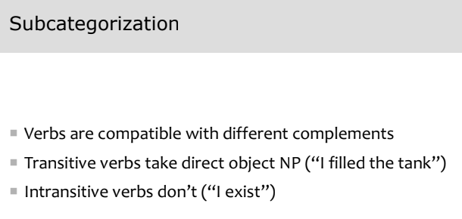 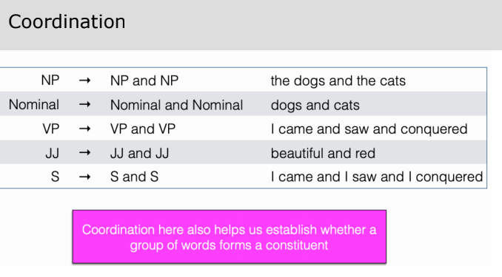 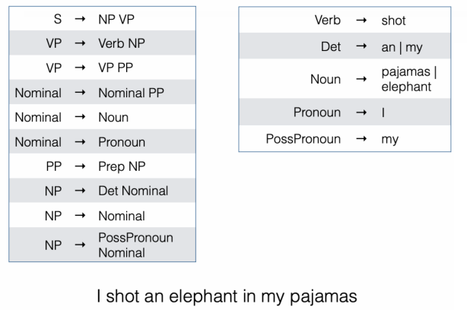 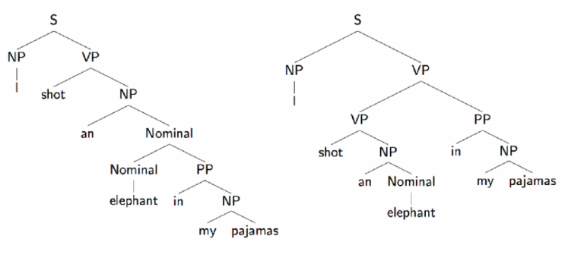

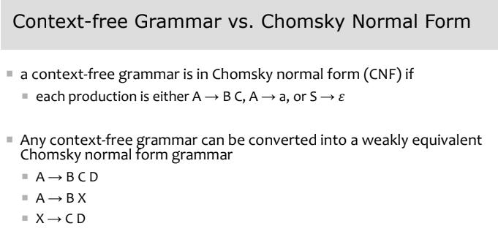 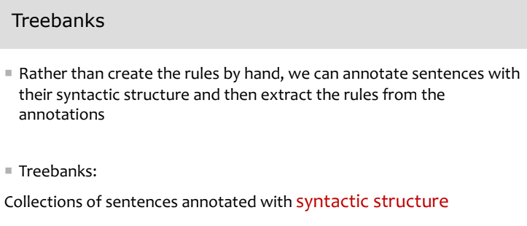 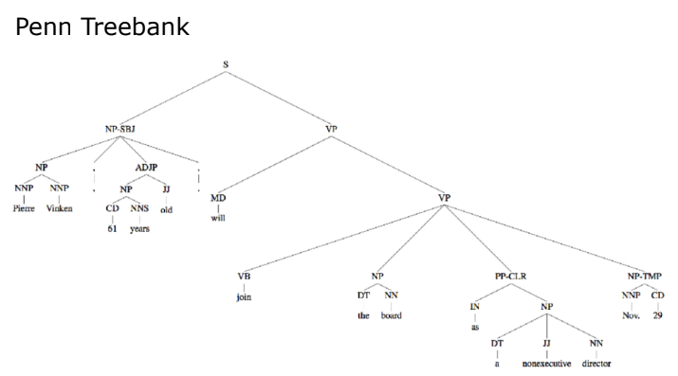

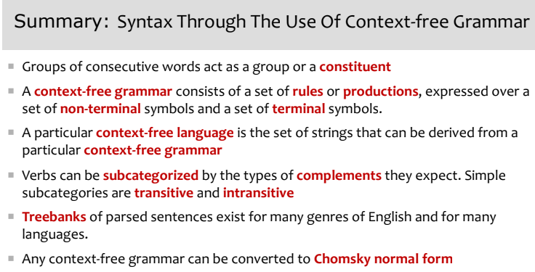 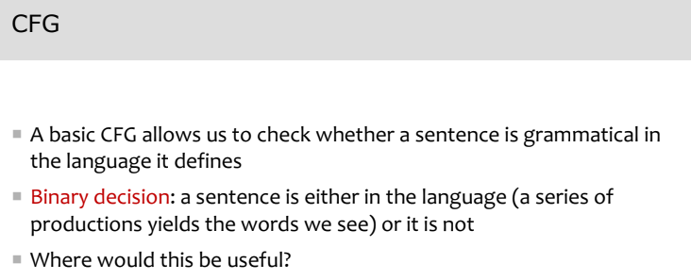 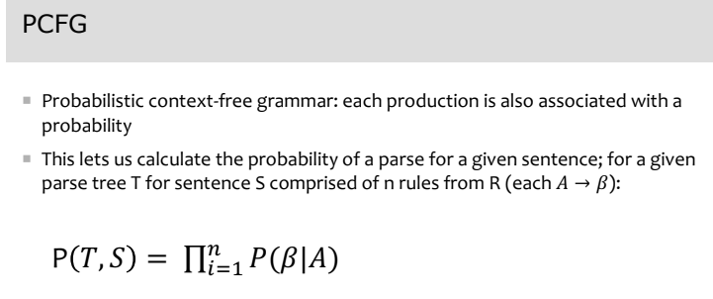 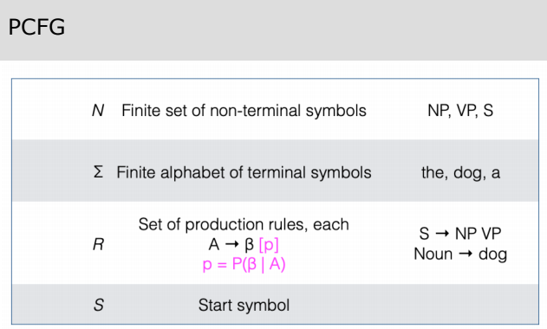 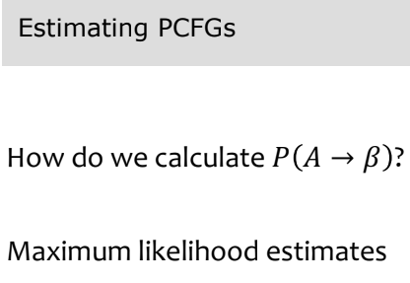 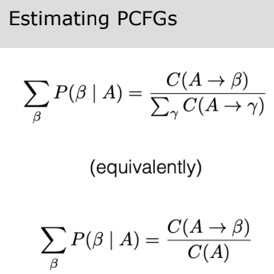

CKY Algorithm for Parsing CFG:

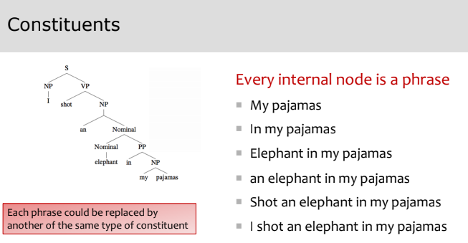 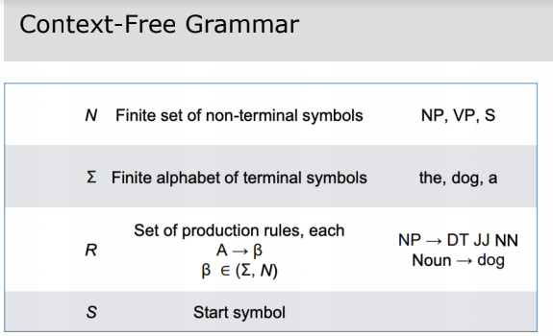 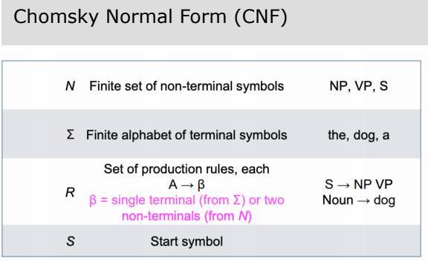

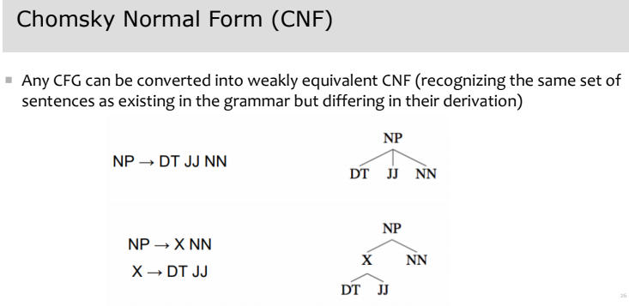

The CYK algorithm for parsing for a grammar expressed in CNF can be expressed as bottom-up dynamic programming.

The subproblems for our dynamic program are all possible spans of contiguous words in the sentence.

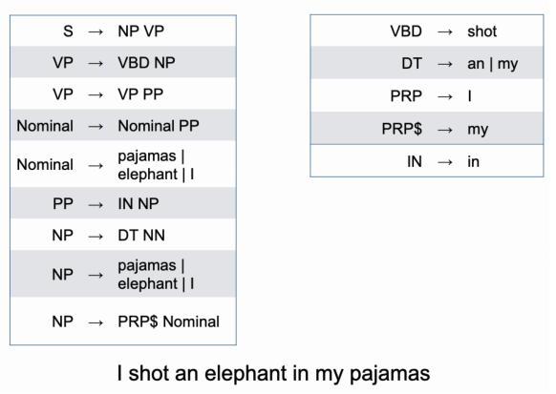 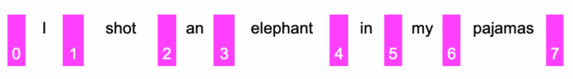 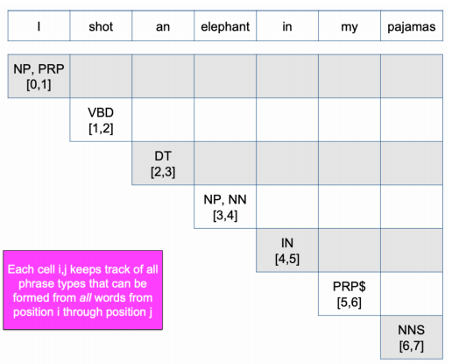 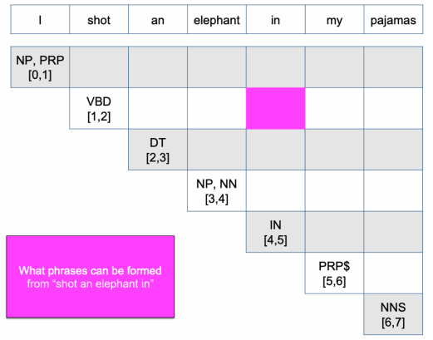 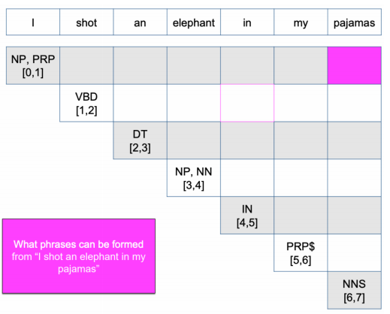 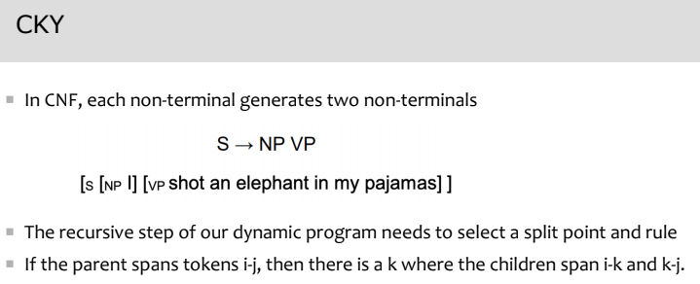 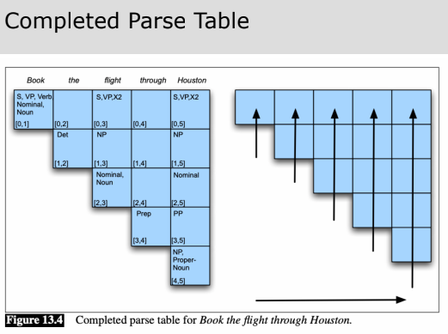 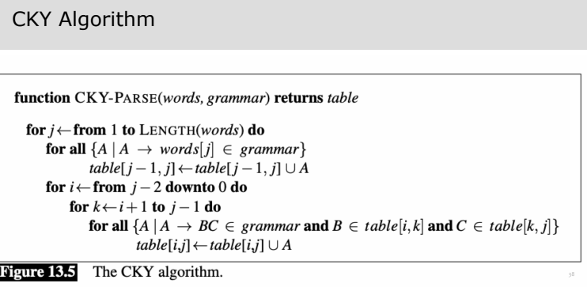 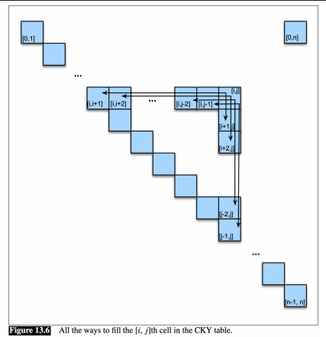 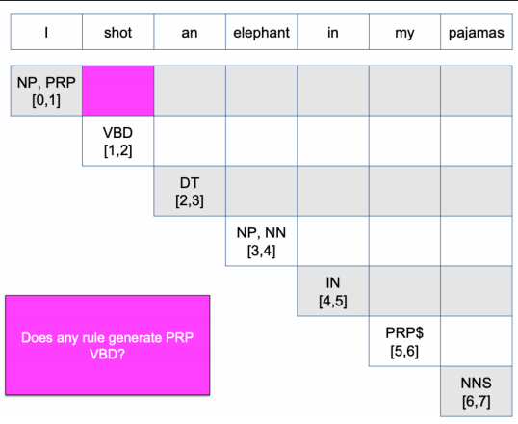 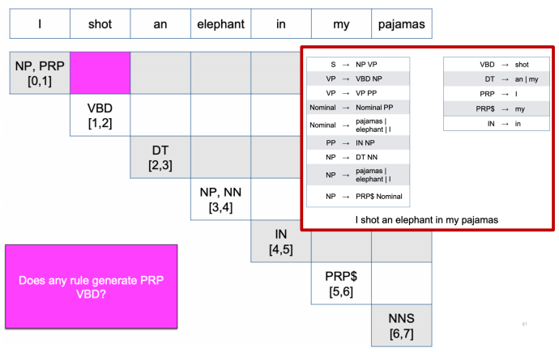 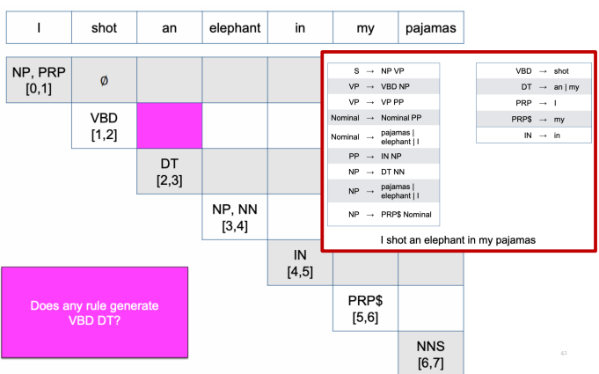 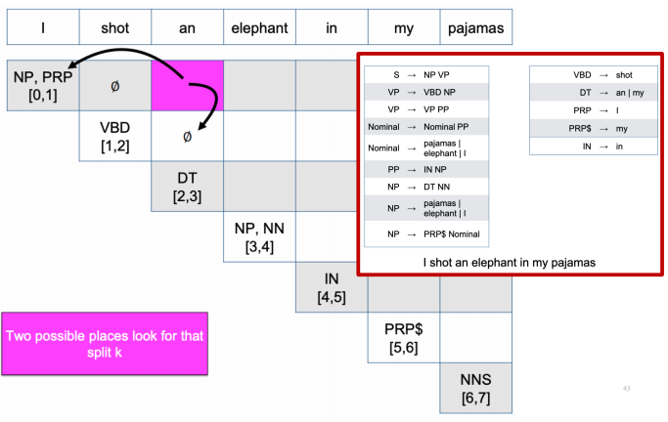 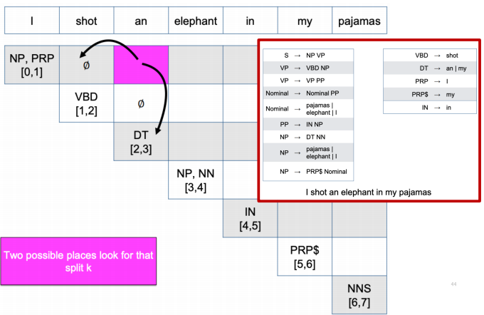 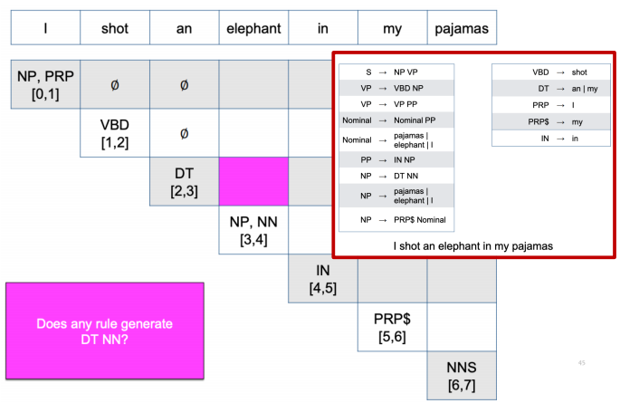 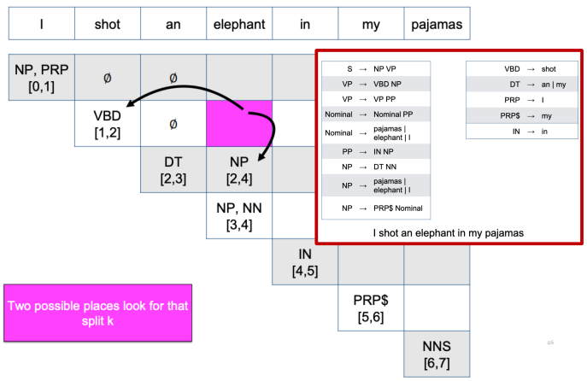 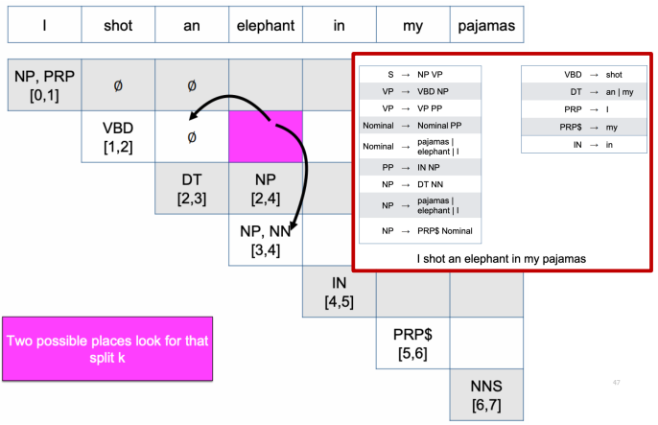 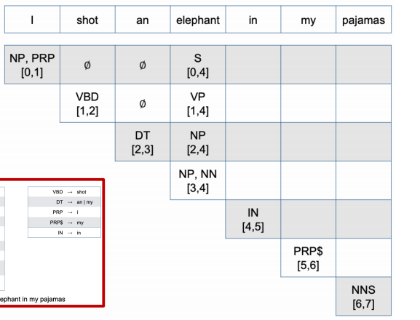 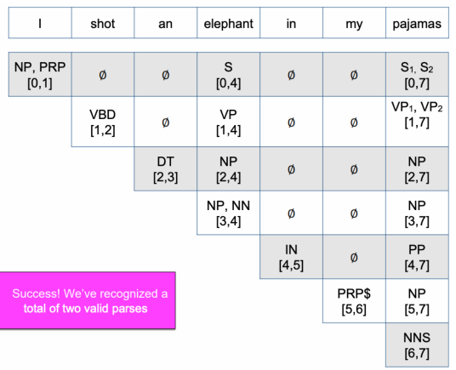

The CKY algorithm allows us to:

1. Recognize whether a sentence is grammatical in the language defined by the CFG
2. Enumerate all possible parses for a sentence

However, the CKY algorithm does not tell us which one of those possible parses is most likely

